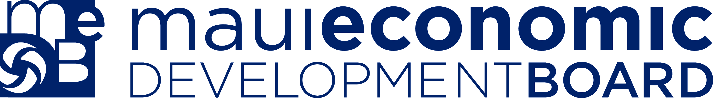

Ke Alahele Education Fund
Final Report

We appreciate your participation in the MEDB Ke Alahele Education Fund program and hope that your project has been a worthwhile and memorable experience. To ensure we can continue to support grants like the one you received, as well as improve our application process, we require you to complete and submit this Final Report.

We know it takes a little time to finish, but this is a critical requirement of our funding procedure and you will be helping other educators and students get grant support in the future.

Grant No.:
Project Title:
Date of Award:
1. Provide an abstract/summary of your award activities in 100 words or less.
(Enter your response in this box)
2. Describe how the awarded funds were spent. Please provide a final expenditure report listing items purchased and including receipts.
(Enter your response in this box)
3. Describe how many students/individuals were reached in relation to what was proposed.
(Enter your response in this box)
4. Discuss the outcomes of the project in relation to the learning goals described in your application. Please explain fully and include future steps planned or anticipated as a result of this project.
(Enter your response in this box)

5. Please describe any unexpected challenges or benefits as a result of the project and how the project responded to these.
(Enter your response in this box)

Please provide high-resolution images, jpg or tiff format on a CD, DVD, or thumb drive. Images can also be sent via Dropbox—please contact the MEDB office at 875-2300 if sending via this online service. Provide finished videos on a DVD or thumb drive. If sending b-roll footage, preferred file size is 1080 (1920 x 1080), but 720 would be acceptable as well. Videos can be delivered, mailed, or sent via Dropbox. Include copies of any publicity you received.

_________________________________________
Signature of Award Recipient

_________________________________________
Date

