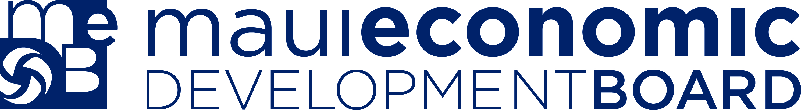

MEDB Ke Alahele Education Fund
Grant Guidelines

Overview

The Ke Alahele Education Fund was created by the Maui Economic Development Board to help local educators, individuals, parent groups and other organizations enhance student learning as well as augment their own professional development. The Fund’s goals are to:

Support needs, actions and efforts in the STEM areas (science, technology, engineering and math) that enhance education systems and activities

Align education initiatives with Focus Maui Nui’s vision, values and strategies (see www.focusmauinui.com)

Promote education experiences that meet or exceed the Hawaii Content and Performance Standards set by the Hawaii Department of Education

Eliminate barriers to access tools that enrich educational opportunities in STEM

We expect to make single-year awards up to $5,000 to qualified applicants. We seek to fund the spectrum of K-12 activities and internships at the post-secondary level. A list of past recipients can be found at www.medb.org/KeAlahele. Supported activities may include but are not limited to:

- Internships for students or educators
- Culture – Science Integration
- Project-based, service-based learning
- Sustainability, renewable energy projects
- Apprenticeships
- Innovative curriculum
- Professional development or training for educators
- Purchase of supplies or equipment to enhance science, technology, engineering and/or math (STEM) activity.

* FOCUS MAUI NUI is an on-going effort spearheaded by the Maui Economic Development Board, Inc. to engage the residents of Maui County in shaping and enacting a long-term vision for our four-island county. For more information, go to www.focusmauinui,com

Review Criteria

The strongest proposals will be those that best meet all or most of the following criteria:

- Proposed project is focused and well defined
- Project identifies clear outcomes and measures of success
- Project involves appropriate partners
- Project budget is concise, relates to the project description, and shows reasonable cost
- Project is innovative, will advance STEM education and aligns with Focus Maui Nui strategies
- Project effectively integrates cultural content with scientific practices
- Project adds to community sustainability
- Project must involve an evaluation/way to measure results
- Project demonstrates excellence and impact in serving organization’s constituency or our community
- Applicant can be accountable for funds
- Applicant must submit final report evaluation to MEDB

Eligibility

- Eligible applicants must be an educator, organization, school or student

Grant Guidelines

- Proposals are for a one-year period
- Grantees may apply annually. To be eligible for subsequent year funding, all former grantees must have completed and submitted their final reports to MEDB.
- All grant proposals should allow up to 60 days for a response
- Applicants should ensure that there is adequate lead-time for processing grant applications including submittal and approval process, receipt of the grant money, and lead-time for long lead items (equipment, etc.)
- Grants are intended to supplement not supplant schools academic programs (i.e., Funds can be used to expand or enhance educational opportunities but not replace or compete with existing funds)
- Grant requests must involve an evaluation/way to measure results
- Educators are strongly encouraged to partner with the community to enhance project-based learning and provide ‘real world’ hands-on experiences. Grants that identify community partners will be given a higher priority
- All grant proposals will be reviewed by the MEDB Education Committee and awarded by the MEDB Board of Directors. Awards will be distributed in one lump sum

Deadline

Application forms are available by calling 875-2300 or can be downloaded from the MEDB website at www.medb.org. Applications are accepted throughout the year; however, some programs such as Robotics may have specific deadlines – check website for the latest information. Incomplete proposal packets will not be reviewed. Please send proposals to:

Maui Economic Development Board, Inc.
MEDB Ke Alahele Education Fund
1305 N. Holopono St., Suite 1
Kihei HI 96753

Reporting Guidelines

A Final Report is required 30 days after grant period ends, and must contain details on how the awarded funds were spent, how many students/individuals were reached (if applicable), the grant, and the overall results of the awarded grant.

If you have any questions about these guidelines or the MEDB Ke Alahele Education Fund, please contact Michelle Cocca at 875-2388.

